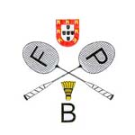
XIII Portuguese International Junior Championships 2021
Caldas da Rainha, 3rd December – 5th December 2021
VISA APPLICATION FORM 2021

TEAM: …………………………………………………………………………………………………..
GIVEN NAME | FAMILY NAME | GENDER | DATE OF BIRTH  (dd/mm/yyy) | NATIONALITY | PASSPORT NUMBER | EXPIRY DATE  (dd/mm/yyy) | FUNCTION

Please return this form to until 3rd November 2021:
Portuguese Badminton Federation – events@fpbadminton.pt

