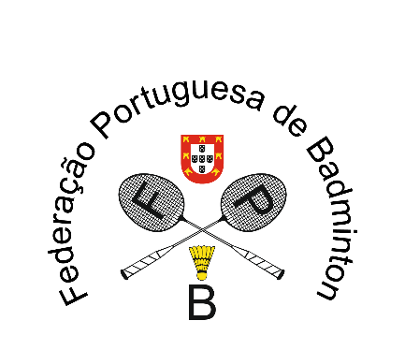

III U17 Portugal Open 2023
Caldas da Rainha, 24 to 26 November 2023
VISA APPLICATION FORM 2023

TEAM: …………………………………………………………………………………………………..
GIVEN NAME | FAMILY NAME | GENDER | DATE OF BIRTH  (dd/mm/yyyy) | NATIONALITY | PASSPORT NUMBER | EXPIRY DATE  (dd/mm/yyyy) | FUNCTION

Please return this form to until October 24, 2023
Portuguese Badminton Federation – events@fpbadminton.pt

