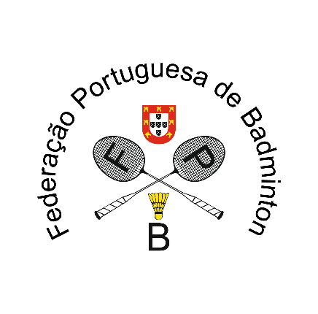 | 58 Portugal International Championships 2023  Caldas da Rainha, March 8 to March 12, 2023  VISA APPLICATION FORM 2023

TEAM: …………………………………………………………………………………………………..

GIVEN NAME | FAMILY NAME | GENDER | DATE OF BIRTH  (dd/mm/yyyy) | NATIONALITY | PASSPORT NUMBER | EXPIRY DATE  (dd/mm/yyyy) | FUNCTION

Please return this form until February 8, 2023 with copy of the passports:
Portuguese Badminton Federation – events@fpbadminton.pt

