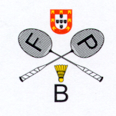 | 55 Portuguese International Championships 2020  Caldas da Rainha, 5 - 8 March 2020  VISA APPLICATION FORM 2020

TEAM: …………………………………………………………………………………………………..
GIVEN NAME | FAMILY NAME | GENDER | DATE OF BIRTH  (dd/mm/yyyy) | NATIONALITY | PASSPORT NUMBER | EXPIRY DATE  (dd/mm/yyyy) | FUNCTION

Please return this form until January 31, 2020 with copy of the passports:
Portuguese Badminton Federation – events@fpbadminton.pt

